PERSONAL INFORMATION | Prince Kwame Affum
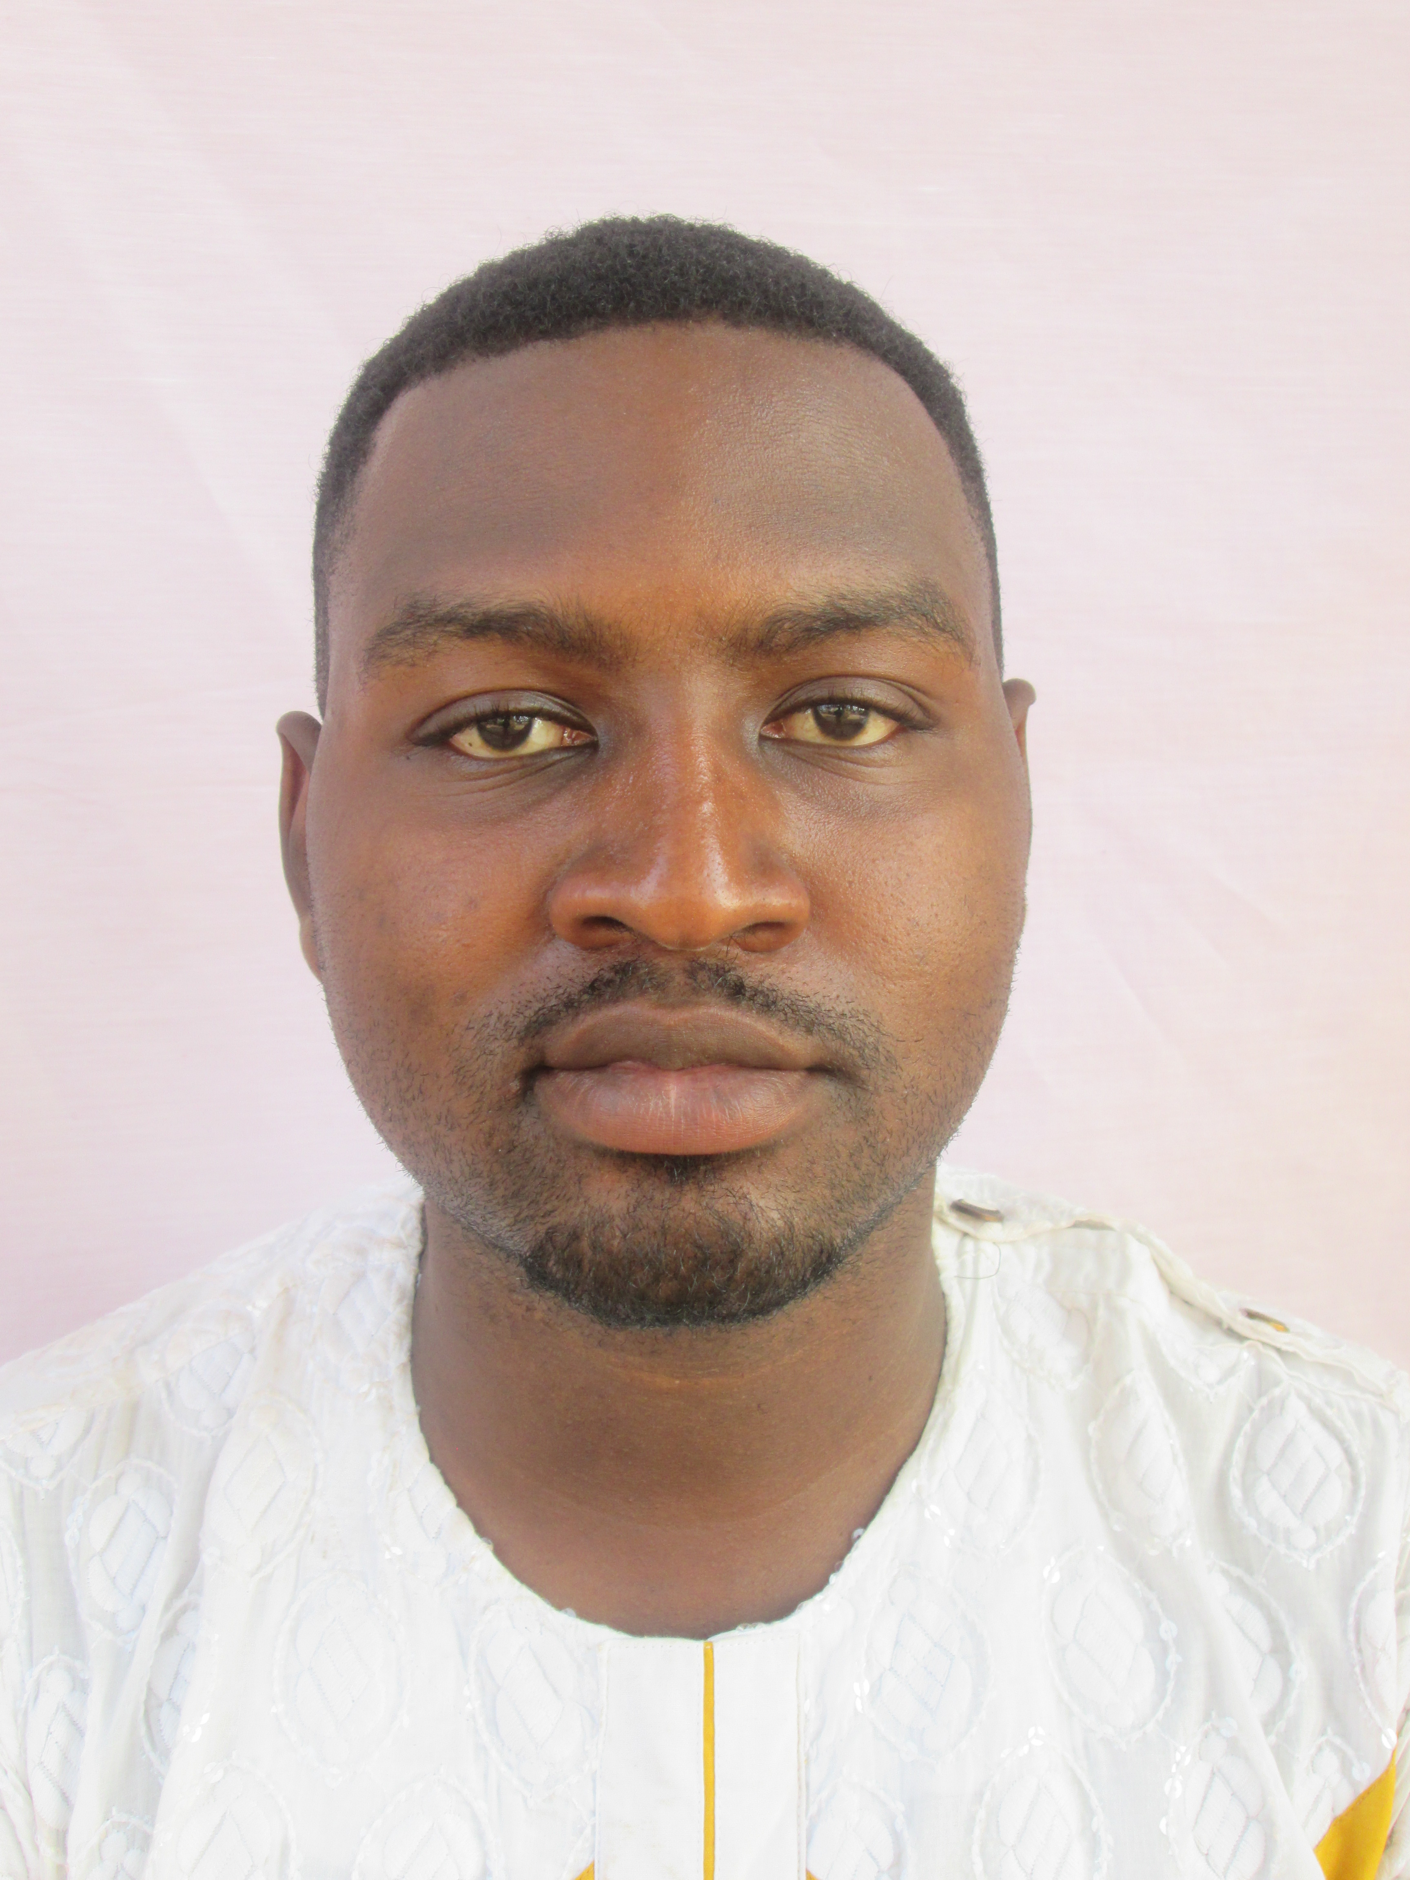 |   SDA, Dormaa Ahenkro, Ghana

(+233) 209584545  (+233) 541064260

prince.affum@uenr.edu.gh

(+233) 541064260
 | Sex Male | Date of birth 19/12/1987 | Nationality Ghanaian

CURRENT JOB  personal statement | Assistant Counsellor  To make the best out of every situation in which I find myself using my creative energy and passionate approach to contribute to the success of any institution I find myself, which will help expand my skill and experience.

WORK EXPERIENCE

Assistant Counsellor (2018 – Present)
University of Energy and Natural Resources, Post Office Box 214, Sunyani (www.uenr.edu.gh)
- Individual and group counselling sessions,
- Organise and facilitate workshops and seminars
- Administer psychological tests
- Provision of responsive and support services to staff and students
- Liaise with Students’ Representative Council on matters that concern the lives of students

Lecturer (2014 - 2018)
Institute of Educational Development and Extension-University of Education Winneba, Post Office Box 25, Winneba-Ghana (www.uew.edu.gh)
- I Lectured Research Methods; Psychological Basis For Teaching and Learning; Philosophy of Education, School Curriculum, Social Change and National Development; and Guidance and Counselling
- I Supervised Students Dissertations and Thesis
- I Supervised Student-Teachers Teaching Practice
Business or sector Education.

Counsellor (2014 - 2018)
Mokkaff Counselling Centre, Post Office Box 2719, Sunyani
- Individual and Group Counselling (Peculiar cases include recovering addicts, domestic abuse and normal personal-social issues)
- Career Guidance
- I Organise and Facilitate Conferences, Seminars, Training programmes and Workshops for Teachers, Security Agencies (Police and Army), Nurses etc as initiatives of the counselling centre or upon request
- I used Psychological Tests to Evaluate Staff Performance and Achievements (Psyche Evaluations) and for other appraisals
Business or sector Mental Health Institution

Counsellor (2017)
Solace Foundation, Ghana
- use of psychometric tests
- Facilitate workshops and seminars
- Individual and group counselling sessions for abused victims, traumatised individuals and attempted cases of suicide victims
Business or sector Mobile Mental Health Clinic

Part-Time Senior Tutor (2015 - 2018)
Centre For Distance Education-University of Cape Coast (Abesim, Sunyani)

- I Lectured Guidance and Counselling for Basic Schools; Guidance and Counselling for Senior High Schools; Adolescent Psychology; and History of Educational Thoughts
- I Supervised Students Dissertations and Thesis
- I Supervised Student-Teachers Teaching Practice
Business or sector Education

Teaching Assistant (2011-2012)
Catholic University College of Education-Fiapre
- I assisted in tutoring Principles of School Administration; Guidance and Counselling for Senior High Schools; Adolescent Psychology; and Theory and Methods of Education
Business or sector Education

EDUCATION AND TRAINING
{ON GOING} Doctor of Philosophy (Guidance and Counselling)
University of Cape Coast – Central Region (Ghana)
Principal courses include counselling the terminally ill, marriage
counselling, and counselling addicts

2012 – 2014 | Master of Philosophy (Guidance and Counselling)
2012 – 2014 | University of Education, Winneba  Central Region (Ghana)
2012 – 2014 | - Principal subjects include Guidance and Counselling, Theories of Personality Development and Adjustment, Uses of Psychological Tests, Curriculum Planning and Designs and Research Methods
2007-2011 Bachelor of Education (Accounting) Bachelor of Education (English)
Catholic University College of Ghana  Fiapre (Ghana)
- Principal subjects include Principles of Management, Statistics, Principles of Administration, Records Keeping and Accounts in a School, Principles of Accounting, Business Communication and Commercial Law among others
PERSONAL SKILLS

Mother tongue(s) | Bono, Twi
Other language(s) | UNDERSTANDING |  | SPEAKING |  | WRITING
Other language(s) | Listening | Reading | Spoken interaction | Spoken production
English Language | Proficient user | Proficient user | Proficient user | Proficient user | Proficient user
Sign Language | Basic user | Basic user | Basic user | Basic user | -
Levels: A1/A2: Basic user - B1/B2: Independent user - C1/C2 Proficient user
Common European Framework of Reference for Languages

Communication skills | - Great communication skills gained through my experience as a Counsellor and an educator  - Good Listening skills and open mindedness gained through my experience as a counsellor  - Friendliness  - Empathy gained through my counselling experience  - Confidence gained through my teaching experience  - Respect for others gained through my counselling experience

Organisational / managerial skills | - Leadership  - Critical thinking, decision making and problem solving  - Ability to manage multi-disciplinary projects

Digital competence | SELF-ASSESSMENT
Digital competence | Information processing | Communication | Content creation | Safety | Problem solving
 | Proficient user | Proficient user | Proficient user | Proficient user | Proficient user
Levels: Basic user - Independent user - Proficient user
Digital competences - Self-assessment grid
 | ICT
- good command of office suite (word processor, spread sheet, presentation software)
- good command of Statistical Package for Social Sciences software gained as a researcher

ADDITIONAL INFORMATION

Publications Affum, P. K., Kuranchie, A. & Mensah, M. K. (2016). The Place of Theory in Traditional Guidance and Counselling. African Educational Research Journal, 4(3):131-139
Affum, P. K., Kusi, H., Mensah, D. K. & Afful-Broni, A. (2013). Serving Two Masters in the Educational Context: Experiences of Working Postgraduate Students at the Department of Psychology and Education, UEW. African Journal of Interdisciplinary Studies. 6(2):13-22

Affum, P.K, Tawiah, G. K & Laryea, P. (2019). Effectiveness of Guidance and Counselling in Senior High Schools at Jaman North District in the Brong Ahafo Region of Ghana. International Journal of innovative research and development. 8(2): 29-33

Affum, P. K. (2020). Theoretical knowledge on group counselling and dynamics; the surest way of helping adolescents in Ghanaian Senior High Schools. European Journal of Educational and Development Psychology. 8(3), 1-17
Appiah, E. A & Affum, P. K. (2019). Child labour: effects of the concurrent roles of working and studying on the academic life of basic school pupils in Ahafo Kenyasi, Ghana. International journal of innovative research and development. 8(1): 76-80
Kuranchie, A., & Affum, P. K. (2021). The Pathways to Student Leadership and Effects of Training on Students Leadership Competence. International Journal of Academic Research in Progressive Education and Development, 10(1), 114129.
Mensah, M. K. & Affum, P. K. (2016). A comprehensive guide to effective Guidance and Counselling. Kumasi: Great Impressions Publications
Mensah, M. K. & Affum, P. K. (2020 Reprint). A comprehensive guide to effective Guidance and Counselling. Kumasi: Great Impressions Publications

Honors and Awards Award of Excellence  Sacred Heart Senior Hifgh School, 2012
Best National Service Personnel of the Year, 2012
The Most Promising Student, 2009

Memberships Ghana Psychology Council (GPC)
European Centre For research Training and development
Ghana National Association of Certified Counsellors (GNACC)
Ghana Psychological Association (GPA)

References | Rev. Dr. Isaac Ishmael Arthur (Head of Guidance and Counselling Unit)  University of Energy and Natural Resources,  P.O. Box 214, Sunyani  (+233) 201377038  Isaac Otoo  Regional Resident Tutor - Brong Ahafo  University of Cape Coast-CODE  Sunyani.  (+233) 240077208 / (+233) 209216645  ikechris10@yahoo.com  Mrs Juliana Ohene  Coordinator, IDEL  University of Education, Winneba  Post office Box 25  Winneba.  (+233) 207731359  julieboato@gmail.com
Dr. Mrs. Cecelia Tutu-Danquah
President,
Ghana National Association of certificated counsellors
Adenta, Greater Accra Region
 | (+233) 24996991

